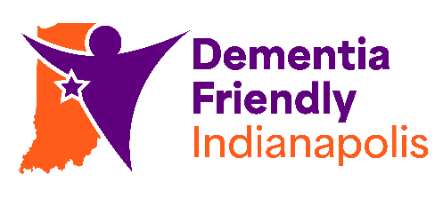
Dementia Friendly Indianapolis
Action Team Member Responsibilities

- Attending monthly action team meetings as schedule allows
- Providing input on the team initiatives, including but not limited to, responding to meeting minutes and voting forms, engaging with DFIndy social media accounts (Instagram and Facebook), emailing me directly, sharing feedback during meetings, etc.
- Sharing DFIndy community events with appropriate parties/connections
- Volunteering in various capacities at DFIndy events when able or interested
- Let us know if you are no longer able to participate in the team

Name:
Date:
Please complete & email form to hhess@cicoa.org.

